**Question-1:**

The quality assurance checks on the previous batches of drugs found that — it is 4 times more likely that a drug is able to produce a satisfactory result than not.

Given a small sample of 10 drugs, you are required to find the theoretical probability that at most, 3 drugs are not able to do a satisfactory job.

a.) Propose the type of probability distribution that would accurately portray the above scenario, and list out the three conditions that this distribution follows.

b.)  Calculate the required probability.

**Answer:**

1. Binomial probability distribution would accurately portray the above-mentioned scenario as it meets below mentioned three conditions:
2. Total number of trials are fixed at 10. (Say n=10)
3. Each trial is binary i.e. either drug will do a satisfactory job or not. (Able to do satisfactory job – Success Unable to do a satisfactory job – Failure)
4. Probability of success (able to do a satisfactory job is same for all 10 trials). Let’s denote it by p.
5. Let’s find the probability of success and failure for drug quality assurance check.

As already mentioned above that probability of drug producing satisfactory result (p) is 4 times more than not producing satisfactory result. (1-p)

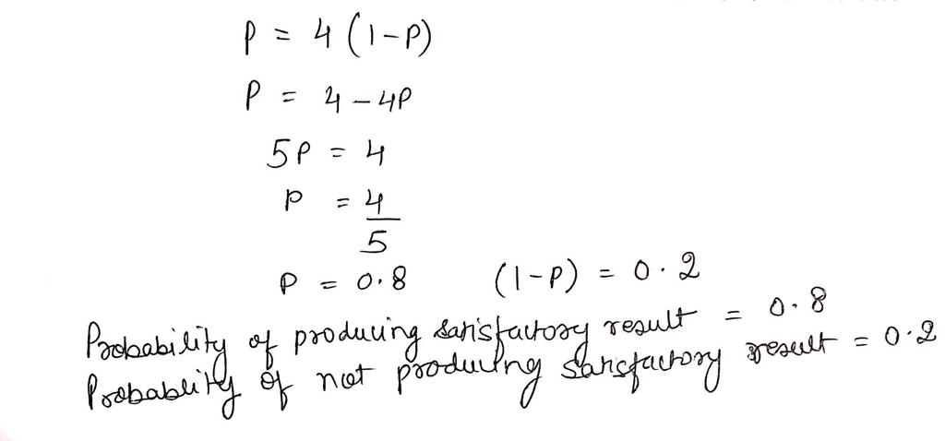

Following binomial probability distribution probability of at most 3 drugs not doing a satisfactory job can be given by P(X<=3). Now create a probability distribution table for P(X<=3).

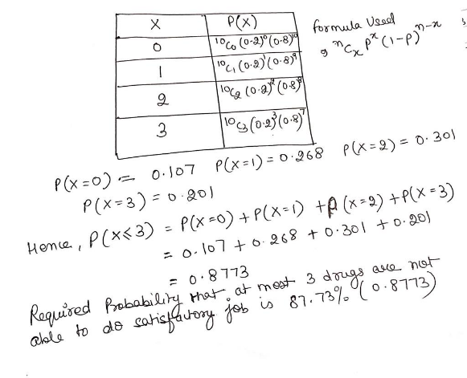**From this figure we can conclude that**

**probability for at most 3 drugs not doing a satisfactory job is 87.73%. (0.8773)**

**Question-2:**

For the effectiveness test, a sample of 100 drugs was taken. The mean time of effect was 207 seconds, with the standard deviation coming to 65 seconds. Using this information, you are required to estimate the range in which the population mean might lie — with a 95% confidence level

a.) Discuss the main methodology using which you will approach this problem. State all the properties of the required method. Limit your answer to 150 words.

b.) Find the required range.

**Answer:**

1. We can solve this problem using Central Limit Theorem properties as it satisfies the below mentioned 3 conditions:
2. Since sample size n > 30 (100 in this case) it follows normal distribution, so it can be assumed that population mean lies close to sample distribution mean.
3. Standard Error = Population Std Deviation / Sqr root of sample size.
4. Smaller the std deviation it means population mean lies close to sample distribution mean.

By Central Limit Theorem we can conclude that.

 Population mean = Sample Mean Margin Error.

1. Margin of error can be calculated by Z* (Z score)

**Population mean will lie between**

**194.26 and 219.74.**



**Question-3:**

a) The painkiller drug needs to have a time of effect of at most 200 seconds to be considered as having done a satisfactory job. Given the same sample data (size, mean, and standard deviation) of the previous question, test the claim that the newer batch produces a satisfactory result and passes the quality assurance test. Utilize 2 hypothesis testing methods to make your decision. Take the significance level at 5 %. Clearly specify the hypotheses, the calculated test statistics, and the final decision that should be made for each method.

b) You know that two types of errors can occur during hypothesis testing — namely Type-I and Type-II errors — whose probabilities are denoted by α and β respectively. For the current hypothesis test conditions (sample size, mean, and standard deviation), the value of α and β come out to 0.05 and 0.45 respectively.

Now, a different sampling procedure is proposed so that when the same hypothesis test is conducted, the values of α and β are controlled at 0.15 each. Explain under what conditions would either method be more preferred than the other.

**Answer:**

**a)**

**Conducting hypothesis using Critical Value Method**

1. Hypothesis: The new batch of pain killers produces a satisfactory result and passes quality assurance test with at most time of effect as 200 seconds.
2. Null Hypothesis (H0) 200 secs

Alternate Hypothesis (H1) > 200 secs.



1. Since the alternate hypothesis contains > sign we can conclude that this is an upper tailed test and critical region lies on right side of the distribution.
2. Making a decision following below steps:



**Since sample mean of 207 secs is less than UCV of 210.6925, therefore it lies in acceptance region, hence we fail to reject the null hypothesis.**

**P-Value Method**

P- value denotes the probability of null hypothesis not being rejected, hence higher the p-value higher are the chances of null hypothesis of not getting rejected.

Follow below steps:

1. Hypothesis: The new batch of pain killers produces a satisfactory result and passes quality assurance test with at most time of effect as 200 seconds.
2. Null Hypothesis (H0) 200 secs

Alternate Hypothesis (H1) > 200 secs.



1. Calculate z-score for the sample mean point on distribution.

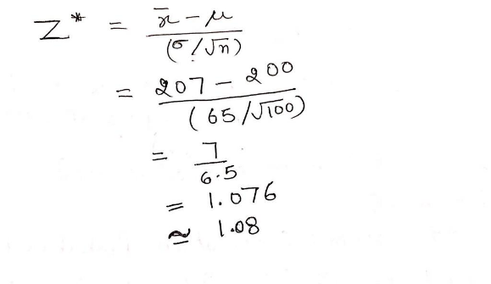

1. Calculate the p-value from the cumulative probability for the given z-score (1.08) using the z-table.

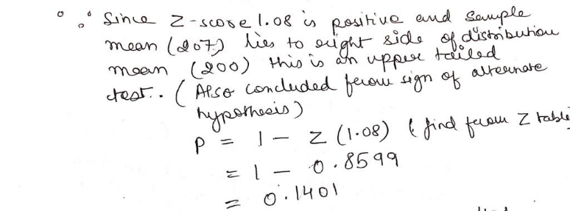

1. Make a decision based on the p-value (one tailed test) with respect to the given value of α (significance value – 5% (0.05).



**Since p – value (0.1401) > 0.05 hence we fail to reject the null hypothesis.**

1. **Type – I (**The hypothesis that the new batch of pain killers produces a satisfactory result and passes quality assurance test with at most time of effect as 200 seconds is rejected even if it holds true)

**Type – II** (The hypothesis that the new batch of pain killers produces a satisfactory result and passes quality assurance test with at most time of effect as 200 seconds is not rejected even if it doesn’t hold true)

As per the first sampling method since value of α = 0.05 < β = 0.45 the chances of not rejecting the drug even if the effect time of the drug is > 200 secs and it doesn’t do a satisfactory job are very high.

**Hence for the case where we have very few/none drugs as a cure to a problem , a drug should not be rejected if it satisfy the time of effect value (<=200) and does a satisfactory job so that it is readily available to patients this sampling technique should be preferred since the probability of type-I error much less than probability of type-II error.**

With other sampling method α = 0.15 = β = 0.15. which indicates that there are equal chances of committing type-I and type-II errors.

**Hence when the case of only making sure the effectiveness of the drug is considered , we can use this sampling technique as probability of rejecting a drug even if does a satisfactory job is same as not rejecting the drug even if it doesn’t do a satisfactory job. Provided we have other drugs available as a cure to problem.**

**Question-4:**

Now, once the batch has passed all the quality tests and is ready to be launched in the market, the marketing team needs to plan an effective online ad campaign for its existing subscribers. Two taglines were proposed for the campaign, and the team is currently divided on which option to use.

Explain why and how A/B testing can be used to decide which option is more effective. Give a stepwise procedure for the test that needs to be conducted.

**Answer:**

A/B testing provides a way to test two different versions of the same component and then compare which performs better.

Two sample proportion tests is used to perform A/B testing by comparing two different samples for each of the taglines.

**Step 1**: Roll out two versions of ad campaign to a set of existing subscribers.

Version 1 (Tag Line 1) Version 2(Tag Line 2)

**Step 2:** Record the responses of subscribers for both Version 1 and Version2 in a table like below. For e.g. consider this response.

|  |  |
| --- | --- |
| **Version 1 (Tag Line 1)** | **Version 2 (Tag Line 2)** |
| **1** | **0** |
| **0** | **1** |
| **1** | **0** |
| **…..** | **….** |

**1 –** Tag line catches the eye of subscriber and they

show interest in ad campaign.

**0 -** Tag line doesn’t catch the eye of subscriber and

they don’t show interest in ad campaign.

Record this data in excel sheet.

**Step 3:** Analyze the conversion rate for both versions.

Version 1 % conversion = No of successful conversions (no of 1’s)/ Total no of subscribers in Version1

Version 2 % conversion = No of successful conversions (no of 1’s)/ Total no of subscribers in Version2

**Step 4:** Assume null hypothesis and alternate hypothesis as below:

H0: Version1 is better than or as good as Version2. (Version 1 >= Version2)

H1: Version 2 is better than Version 2. (Version2 > Version1)

**Step 5:** After recording data into excel go to XLSTAT and select two sample proportion test option.

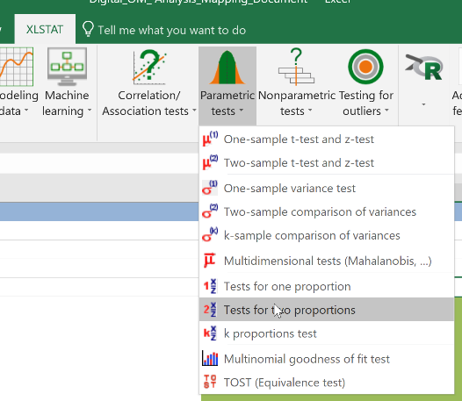

Input the frequency and sample size for both versions in below grid in excel. Select the range of cells for result.

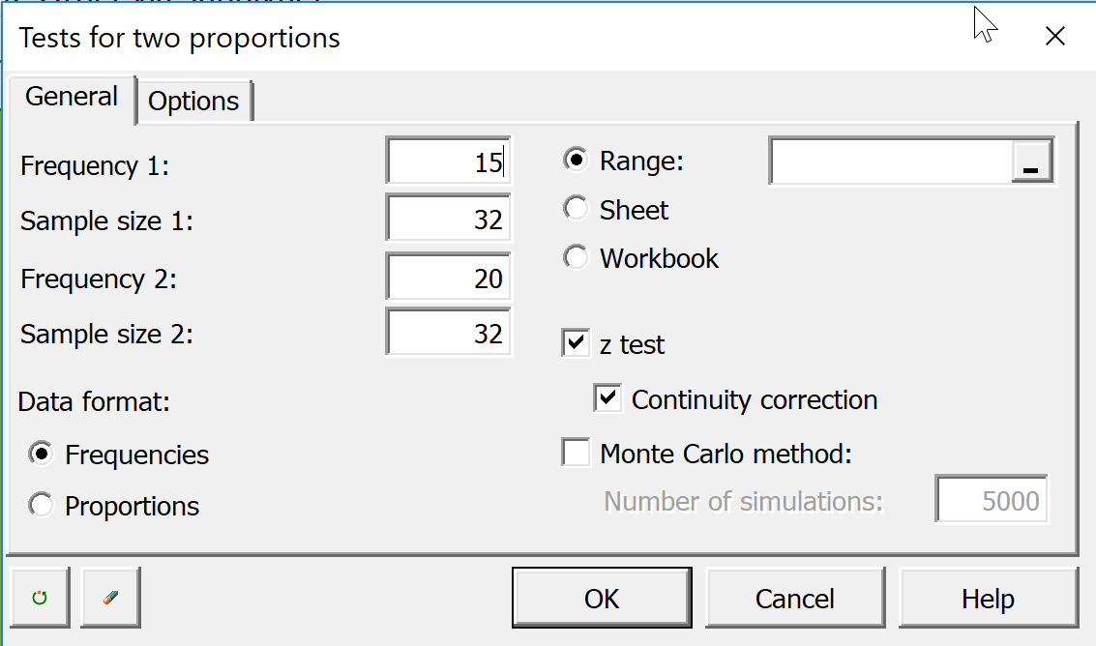

Input the alternate hypothesis as Proportion 1 – Proportion2 < D, keep significance level as 5. Click OK.

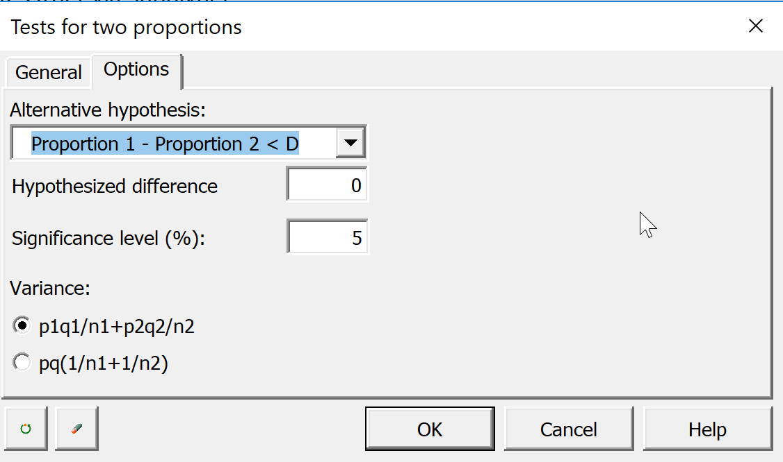

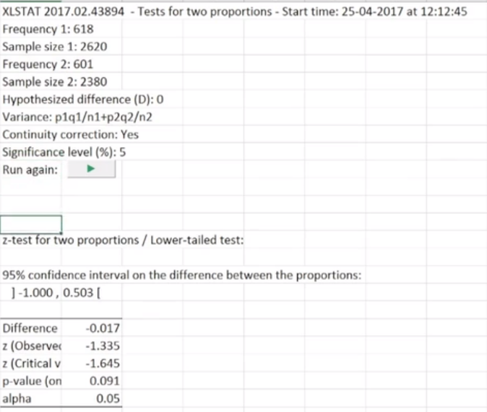**Step 6:** We will get the results of two sample proportion test. Result will look like as below in general.

**By comparing the p-value with value of alpha (0.05) in our case we can conclude up to certain extent that whether null hypothesis can be rejected or not.**

**if p-value > alpha (0.05) - null hypothesis cannot be rejected. (Version 1 better than Version2)**

**If p-value < alpha (0.05) – null hypothesis can be rejected. (Version 2 better than Version1)**

Additionally, we can wait for some more time and perform same test again on a large set of sample data to be more conclusive.